Instructions to register for SGMP Chapter Meeting
Go to the Chapter Website.

Click Here
___________________________________________________________
Once on registration page there are two “Register Now” tabs. Click on either one.

If you are a member you will use an Account Login. Guests will click on “Don’t Have An Acount” and then “Continue as Guest”
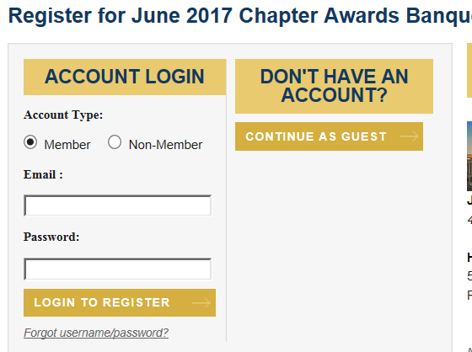

You will need to fill out registration. The click “Continue”
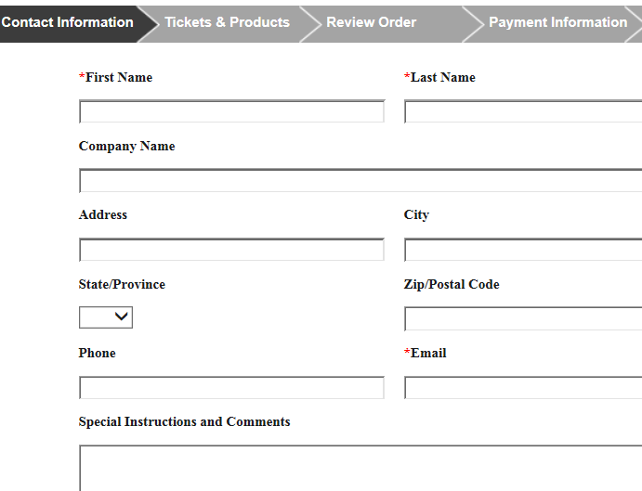

You will select to add the guest ticket.

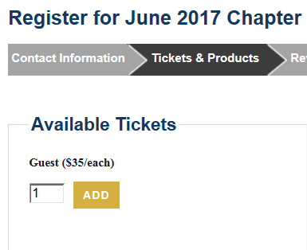
Click on ADD

You will be asked a question about photographs being taken.

You will proceed to the secure payment page to complete the transaction. Using a credit card.
A receipt will be emailed to you once transaction is completed.

